21K-3278

Sohaib Sarosh Shamsi

Q2. a

|  |  |  |  |  |
| --- | --- | --- | --- | --- |
| a | b | C | D | F |
| 0 | 0 | 0 | 0 | 1 |
| 0 | 0 | 0 | 1 | 1 |
| 0 | 0 | 1 | 0 | 0 |
| 0 | 0 | 1 | 1 | 1 |
| 0 | 1 | 0 | 0 | 1 |
| 0 | 1 | 0 | 1 | 1 |
| 0 | 1 | 1 | 0 | 0 |
| 0 | 1 | 1 | 1 | 1 |
| 1 | 0 | 0 | 0 | 0 |
| 1 | 0 | 0 | 1 | 0 |
| 1 | 0 | 1 | 0 | 0 |
| 1 | 0 | 1 | 1 | 0 |
| 1 | 1 | 0 | 0 | 1 |
| 1 | 1 | 0 | 1 | 1 |
| 1 | 1 | 1 | 0 | 0 |
| 1 | 1 | 1 | 1 | 1 |
|  |  |  |  |  |

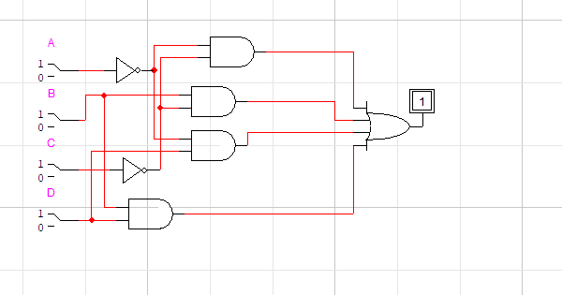

Q2 b

|  |  |  |  |
| --- | --- | --- | --- |
| a | b | C | F |
| 0 | 0 | 0 | 0 |
| 0 | 0 | 1 | 1 |
| 0 | 1 | 0 | 0 |
| 0 | 1 | 1 | 1 |
| 1 | 0 | 0 | 1 |
| 1 | 0 | 1 | 1 |
| 1 | 1 | 0 | 0 |
| 1 | 1 | 1 | 1 |

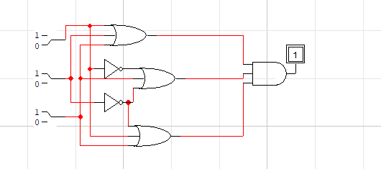

Q3 a

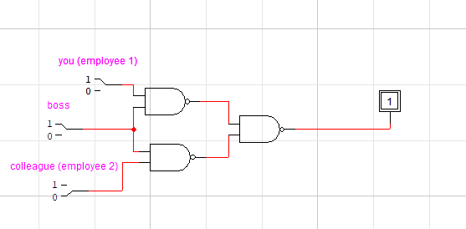

Q3 b

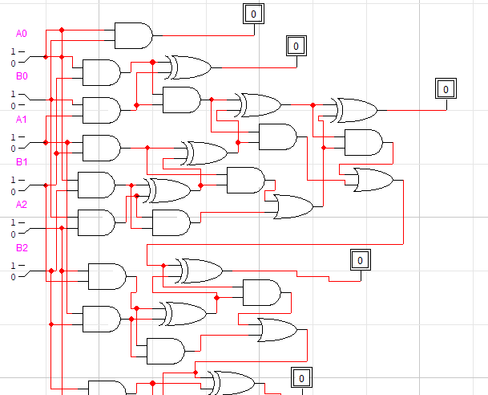

Q4 a

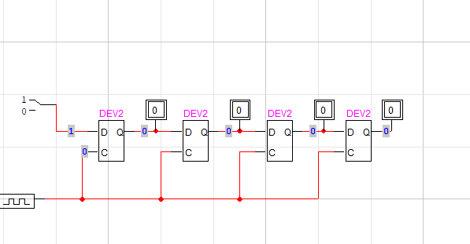

Q4 b

